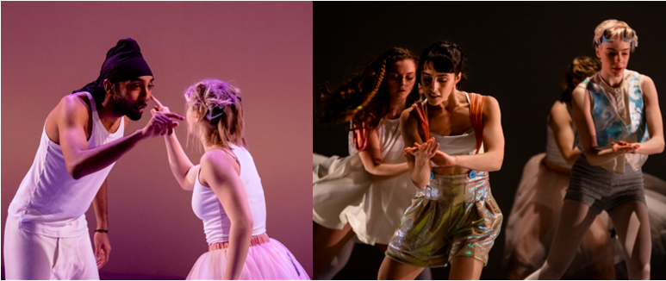

Sweetshop Revolution is seeking dancers for creation and tour of new work

Sweetshop Revolution is seeking dancers of any gender who are mischievous, warm, open-hearted and fun for the creation and tour of a new five-person family dance show in Wales.

We are eager to receive applications from dancers of all backgrounds and welcome applications from new graduates (trained to professional standard). We are particularly keen to hear from Wales-based dancers. Dancers need be open to contributing to the creative process and working collaboratively, as we work often from improvisation.

How to apply: Please send your CV, a short video (this doesn’t need to be a fancy showreel, any footage will do, we are interested in your movement ability, not your video-editing skills!), and any other material that you feel is relevant to auditions.sweetshop@gmail.com. In your email, please include a couple of sentences about yourself – a full cover letter is not necessary, but we would like to know a little about you.

If you have any questions please feel free to email us at auditions.sweetshop@gmail.com or visit our website https://www.sweetshoprevolution.com/

Audition dates: 7th and 8th January - Cardiff and London respectively. Exact location and time tbc

Project dates: Creation rehearsals in Wales from 6th February to 4th of March. Production rehearsals May 22nd, 23rd and 24th. Performances on May 25th (Barry), June 7th (Milford Haven) and June 24th (Aberystwyth). There will be further touring opportunities in the future.

Paid above Equity minimum.

We look forward to hearing from you!

